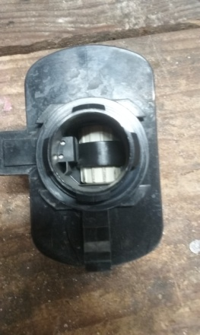
This is the ESIM. Notice that there is a tab on the bottom. To remove the ESIM, depress the tab, and turn the ESIM about 1/8 of a turn. There is a rubber o-ring that should also be removed and changed.
To get to the tab, I had to slightly bend back the metal shroud on the gas tank.
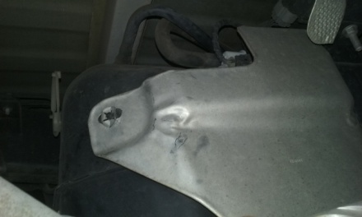
There is a retainer ring that I had to bend to get the shroud out of the way. I was then able to reach up under the shroud to depress the tab.
Here is the ESIM installed.
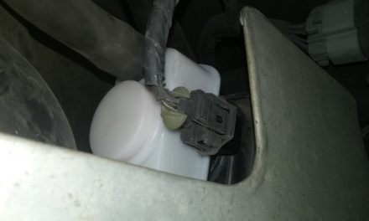
I then installed a new filter.
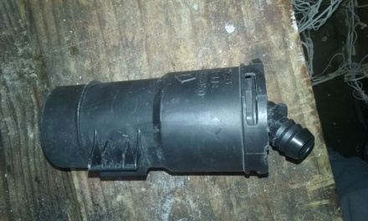
Here is the filter installed. It is under the wheel well by the fuel fill hose.
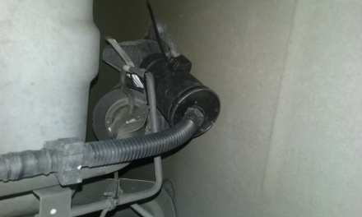
I hope these pictures are helpful for anyone else doing this.

