ESIM with cover cut off.
ESIM with diaphragm
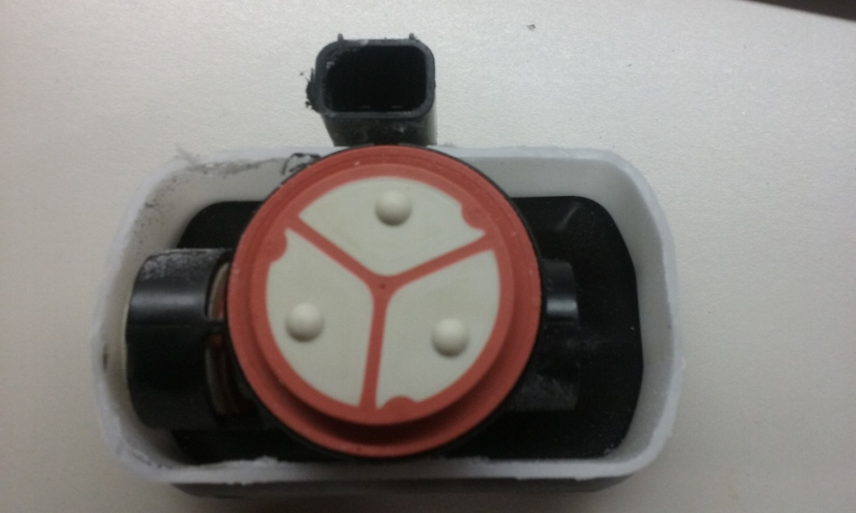
ESIM without diaphragm
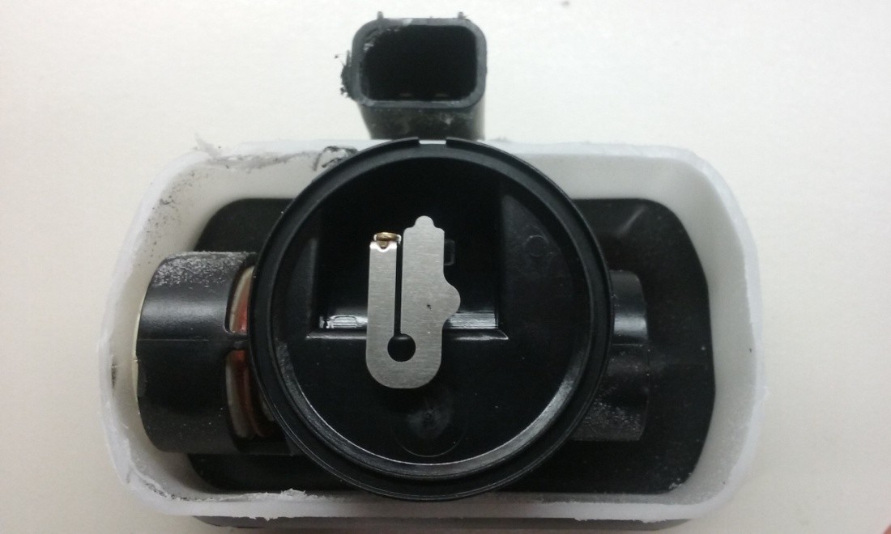
This picture shows the contacts that are connected when the diaphragm is either pulled or pushed in (not sure which).
There are also two plungers in a tube under the diaphragm. One plunger can be seen to the left of the diaphragm.

